Deaths in Game of Thrones

| Pedro Elias  89519  Lisbon, Portugal  pedro.j.p.elias@tecnico.ulisboa.pt | Raquel Santos  89533  Lisbon, Portugal  [raquel.bento.santos@tecnico.ulisboa.pt](mailto:raquel.bento.santos@tecnico.ulisboa.pt) | Tiago Afonso  89546  Lisbon, Portugal  tiago.francisco.a@tecnico.ulisboa.pt |
| --- | --- | --- |

# ABSTRACT

This report describes the project developed for the Information Visualization course at Instituto Superior Técnico. The project consists of a visualization about the deaths of the *Game of Thrones* TV show and their relation with the book collection *A Song of Ice and Fire*. It is developed using HTML, CSS, JS and d3.js framework.

The visualization allows us to analyze all the deaths along the different episodes and examine the different conditions where each of them occurred, such as killing method, allegiance of the involved or location of the death. There is the option of selecting visualizing the deaths or kills and is also the possibility of interacting with all the idioms using a global filter that allows us to explore the attributes of each kill or death in a more detailed way.

## Author Keywords

Information Visualization; InfoVis; Game of Thrones; A Song of Ice and Fire; Deaths; Kills.

## ACM Classification Keywords

Human-centered computing: Visualization: Visualization application domains: Information visualization.

# INTRODUCTION

The domain tackled are the deaths in the TV show *Game of Thrones* that occurred on-screen. *Game of Thrones* is one of the most famous shows of all time, and it is well known for frequently killing characters, either being part of the main cast, or background characters.

The popularity of the show makes it an interesting subject for data analysis and the creation of visualizations which allow the user to extract more information from each death.

Some questions that could be answered with visualizations regarding this problem domain are:

1. How was the evolution of the number of kills for each character through the seasons?
2. How was the evolution of the killing method for each character through the seasons?
3. Which houses suffered the most casualties?
4. Which episode and season has the most deaths?
5. Which houses have the most conflicts between each other?
6. Where did most kills take place?
7. Which species had the most deaths?
8. Which gender has the most kills and deaths?
9. There is a preferred killing method according to the killer’s house?
10. Is the location of the deaths a factor when choosing the killing method?
11. What percentage of TV show deaths were based on the books?
12. Did the deaths in the TV show and the books occur by the same chronological order?

Currently there are no known tools to automatically collect and process data for deaths of characters in a TV Show. All the data needs to be imputed and verified manually.

Recording and analyzing the deaths in a TV Show whilst comparing them to the events of the original work (the books) not only allows for a better understanding of the evolution of characters, their locations throughout time, the interactions they had with other characters, but also the impact of battles or other important events on characters and houses.

Comparing the deaths in the TV show and in the books also helps seeing how much of the show was adapted from the books and where it diverges. Some characters only exist in the show, others only exist in the book, so it is interesting to analyze the difference in their fates.

# Related Work

There are many analyses on *Game of* *Thrones* available online, due to the popularity of the books and the show. While all focus on the *Game of Thrones* domain, some use completely different data (for example, the conversations between characters in the book), or try to answer different questions:

* Interactive visualization of *Game of Throne* deaths [1]. It uses the same initial dataset we used to analyze the show deaths. However, the visualization is very static and is too focused on a single character at a time, which does not allow the user to answer all the previous questions. Some idioms have scalability issues and the filters are insufficient for our needs.
* Narrative chart [2]. The domain of this visualization is the interactions between characters in the TV show and their locations throughout time. It also provides information on screen time. The interactions focused by the visualization were not used in our dataset since we mainly focus on deaths.
* The Chaos Ladder [3]. It focuses on characters and their number of appearances in the TV show. While it also shows their life status, it does not have any additional information on what happened in each death, so it does not answer our questions.
* Narrative structure of *A Song of Ice and Fire* [4] creates a fictional world with realistic measures of social complexity. This research paper thoroughly analyses the narrative and interactions between characters to measure the complexity of the fictional world with our own. Since we are mostly interested in the deaths and comparison between show and book, it does not answer our questions.
* Illustrated *Game of Thrones Deaths* [5] uses a similar dataset to analyze each death in the TV show. Even though it uses idioms such as a map and dot plots, it lacks the filters needed to answer our questions and its purpose is to guide the user to a predetermined analysis, lacking interactivity.

# The data

The data was obtained from two different datasets being the first one about the deaths in the TV show [6] and the second one referring to the deaths that occurred in the book collection [7].

Initially, we kept all the data from the first dataset and joined the columns of the second with an outer merge. Then, we removed some lines to keep only the characters that have died in the TV show and appeared in the first dataset.

We removed the repeated columns and introduced two derived measures to analyze if the character appeared in the books and to differentiate the deaths of the animals.

As part of the cleaning process, we removed repeated characters that appeared with different names, corrected wrong values and introduced the missing values based on research on some wikis dedicated to Game of Thrones [8] and A Song of Ice and Fire [9]. Also, it was added sentinel values for the missing values that did not apply.

During the implementation, some changes were made to adjust the data to the problems that start appearing and that were not predicted at first.

Considering that we are treating the killer and the killed characters in the same way, we introduced columns with the characteristics of the killer. All this information was manually introduced based on our knowledge from the TV show and the previously mentioned wikis.

Additionally, we transformed the columns related to the death in the book into the estimated death, converting the chapters into episodes according to the narrative [10].

To simplify the representation of the deaths of the animals, we introduced the allegiance “Animal” and changed this value for all.

To keep the legibility of the chord diagram, considering that we had 278 characters, we had to introduce two new columns with the names that would be represented. The characters with higher number of kills are represented by their name and the remaining are aggregated by their allegiance.

To avoid having redundance in the killing methods, we aggregated some similar methods and removed the additional explanations.

To represent the points in the map, it was introduced two columns with the coordinates of each location. These coordinates were estimated considering the annotated maps that we found online.

Finally, we removed the columns related to the introduction of the character in the book and the death year considering that it did not follow the theme of the visualization. Also, we ended up deleting the two derived measures initially introduced, considering that we could represent the same data without them after the modifications.

Besides the reunited data, we also wanted to find the episode of introduction for each character but, while it was possible to manually find for the main characters, it would be impossible for a large amount of characters. This would be used to compare the presence of the characters in the TV show and in the books considering that we also had the book chapter of introduction. To compare both narratives, we tried to find additionally the killer of each character in the book, but we couldn’t find it.

# Visualization

In this section it will be described all the idioms implemented in the visualization and it will be explained all the choices that led to the final result.

## Overall Description

The visualization is showed in Figure 1. It is composed by the “Deaths/Kills” button and the filter menu on top. The button is used to choose whether kills or deaths are shown, in cases where there is a difference between them (a specific house’s kills is different from their deaths, but a season has the same amount of kills and deaths). The filters allow to aggregate the deaths or kills by season, books, character, house, killing method, gender, nobility or animals. There is also the indication of the current filter and a button to remove it on the right side, to simplify the perception of the current state and to ease the change to the default overall view. Besides this filtering, by clicking in each idiom, it will apply the correspondent filter to the

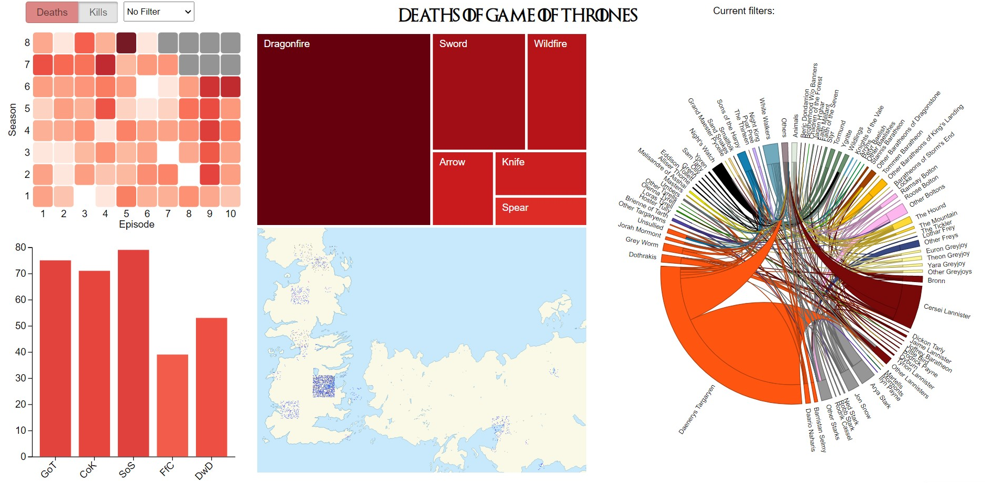

Figure 1. Overview of the visualization.

remaining. Clicking on a selected option will remove the applied filter for all idioms.

The visualization is divided in 5 idioms, those being:

* A **heatmap** representing the number of deaths or kills by each episode of the different seasons, being the episode on the x-axis and the seasons on the y-axis. For a character that died in the books, it will appear a red boarder on the square correspondent to the estimated episode of death in the book. By clicking on one of the squares it will apply the filter to the selected episode and by hovering it will show the exact number of deaths or kills.
* A **tree map** representing the six most frequent killing methods where the size of each square corresponds to the quantity of occurrences. The click and hover are similar to the described for the heatmap, applied for the selected killing method.
* A **chord diagram** representing the relations between the killer and the deceased character and their allegiances. Each node represents a character or an aggregation of characters per house, for legibility purposes as mentioned in the previous section. By clicking on a border or a name it will only show the arcs for that character or group, fading the remaining and apply the filter for its allegiance. By hovering a border or a name, it will show the total percentage of kills of the character or group and on the border will fade the arcs correspondent to the remaining characters. By hovering an arc, it will show the percentage of kills between the two characters or groups represented by it.
* A **bar chart** representing the amount of characters that appear in each one of the five books where each bar corresponds to a book. The click and hover are similar to the described for the heatmap and tree map, applied for the selected book.
* A **map** where each pin represents the location of each death. The shape of the pin represents the nobility of the killed character, being a square for noble characters and a circle for the remaining. The gender is represented by color, being pink for female characters, blue for male characters and grey for the unspecified. By clicking on each point, it will apply the filter to its location. By hovering it will show the names of the killer and the deceased, the location of the death, the method used and the season and episode where it occurred.

## Rationale

In our first sketch we had the “Deaths/Kills” button and a filter menu with the current filter options. As idioms, it included:

* **A bar chart** representing the number of deaths per episode where each bar would correspond to an episode of a season. This option was replaced by the **heatmap** considering the large number of episodes being represented.
* **A heatmap map** representing the density of deaths for each location and a variant of the **map with pins**. To simplify the visualization, we choose to use only the **map with pins** since it represents the individual location of the deaths and allows to see the dispersion.
* **A network diagram** where each node represents a house. This was replaced by the **chord diagram** to allow to compare the number of conflicts between the different houses.
* **A bubble chart** with four options of filters to represent the book status, killing method, species killed and the presence in books. To simplify the representation, we turned this idiom into two and represented the remaining data in other ways. The book status was represented in the second sketch as a circle with one of three colors (green for alive, red for dead and grey when the character doesn’t appear) next to the character’s name in the chord diagram. The killing method is now represented by the **tree map** to reduce the amount of unused space. The species killed can be visualized using the filters by animal. The presence of the characters in the books is now represented in the **bar chart**, easing the comparation of the number of appearances per book.



Figure 2. First sketch

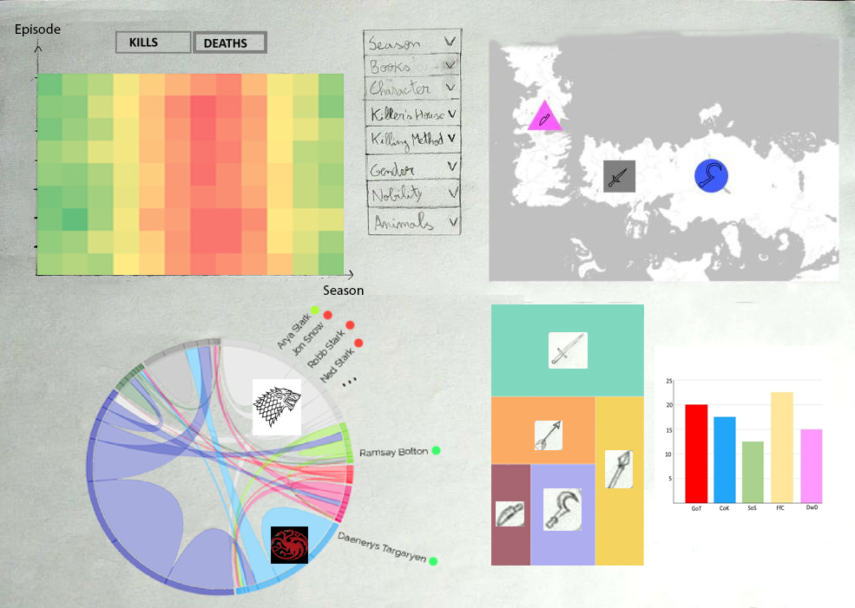

Figure 3. Second sketch

After the second sketch, the changes were minimal:

* In the tree map, instead of representing the killing methods with an icon, we opted to represent them with text considering that not all of them could be represented visually.
* In the chord diagram, instead of representing all characters, considering the substantial number of names, we only represent the characters with more kills, being the others aggregated by their house. To simplify the representation, the book status was removed considering that it didn’t apply to the aggregation of characters and that this data could be visualized using the bar chart (if the character was present in the books) and the heatmap (if the character died in the books).
* In the map, instead of having the shape of the pin distinct for animal, we only considered noble characters as a square, and the remaining as a circle.



Figure 4. First prototype

For the first prototype, we implemented the heatmap, the tree map and the chord diagram. After this the color chosen for the house Targaryen was changed to avoid confusing it with the color scheme of the other idioms. Also, the heatmap animations were changed since they gave the idea that the data was being replaced and not only filtered. Besides this, we implemented the bar chart and the map as planned and added the indication of the current filter as explained in the previous section.

These idioms were chosen considering that each one highlights a different attribute, avoiding redundant information and representing all the data available. Also, we tried to use more intuitive idioms to ease the comprehension of the data.

## Demonstrate the Potential

This section will describe the potential of our project, answering some of the previous mentioned questions:

1. How was the evolution of the number of kills for each character through the seasons?

This is directly observable in the heatmap after applying the filter for the specific character and the option “Kills”. As an example, we selected the character Ramsay Bolton (Figure 5) and in the heatmap (Figure 6) we can see the number of kills per episode.

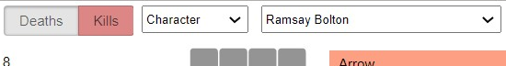

Figure 5. Filter options for Ramsay Bolton kills

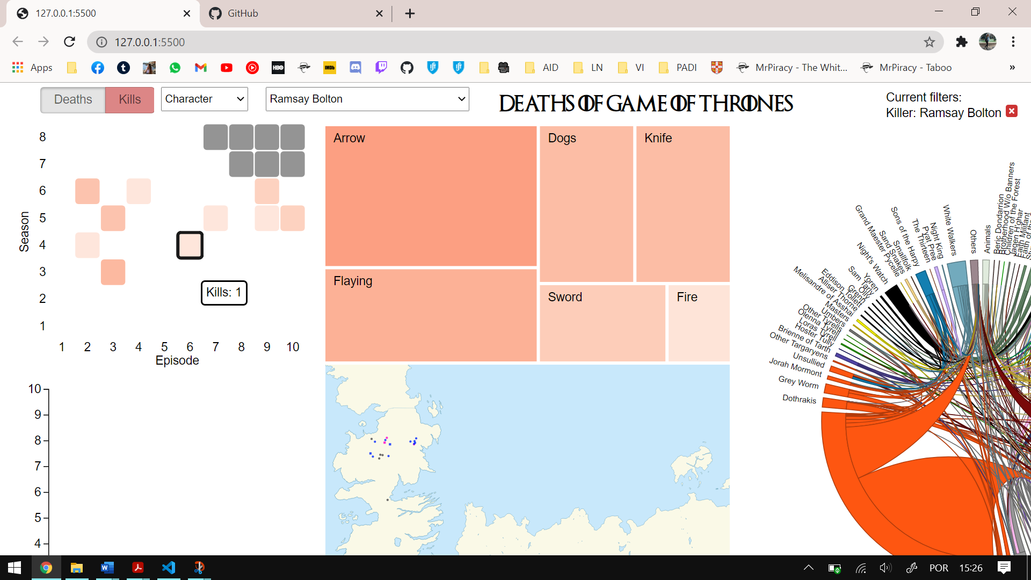

Figure 6. Number of kills by Ramsay Bolton

1. How was the evolution of the killing method for each character through the seasons?

Filtering by a character and selecting each episode on the heatmap, we can see on the tree map the killing methods used, allowing to analyze this evolution. Using the previous example, selecting the second episode of season 6, we can see in the tree map the killing methods used (Figure 7). Analyzing the methods for the rest of the episodes, we can see this evolution.

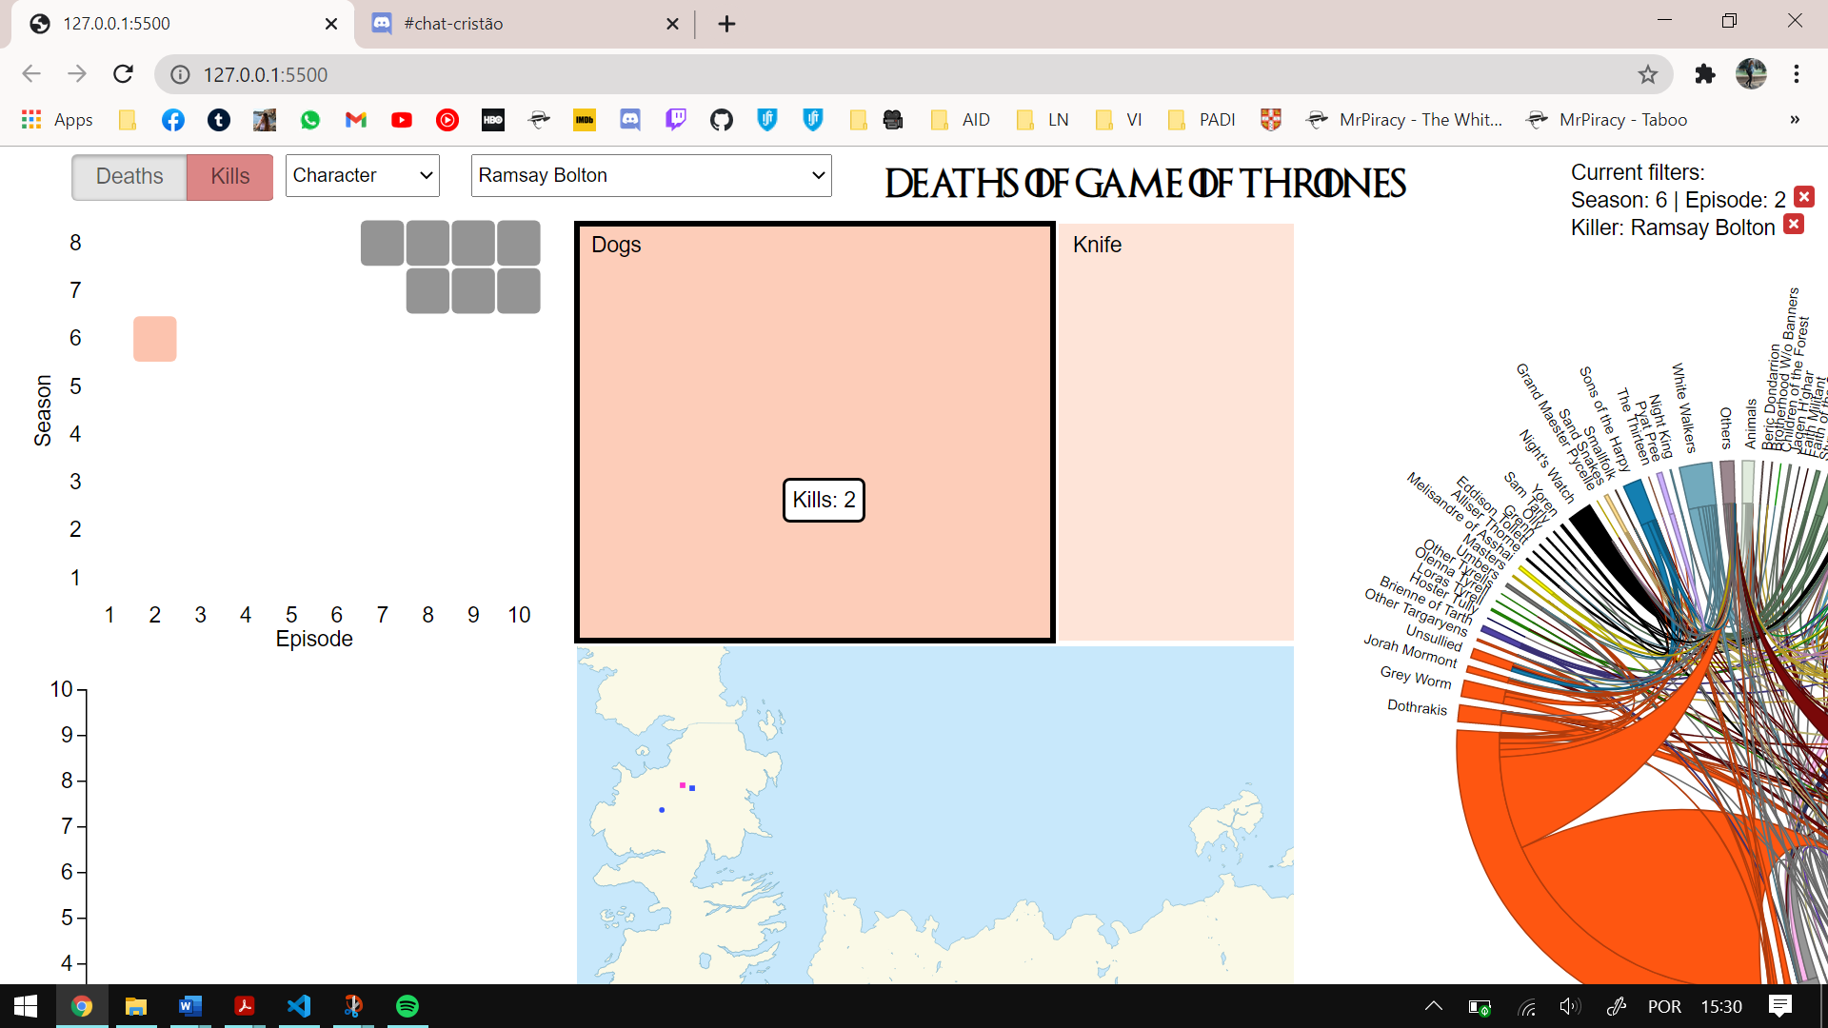

Figure 7. Killing methods used by Ramsay Bolton

1. Which species had the most deaths?

Filtering by each animal and the option “Deaths” (Figure 8), the heatmap will show the number of kills (Figure 9).

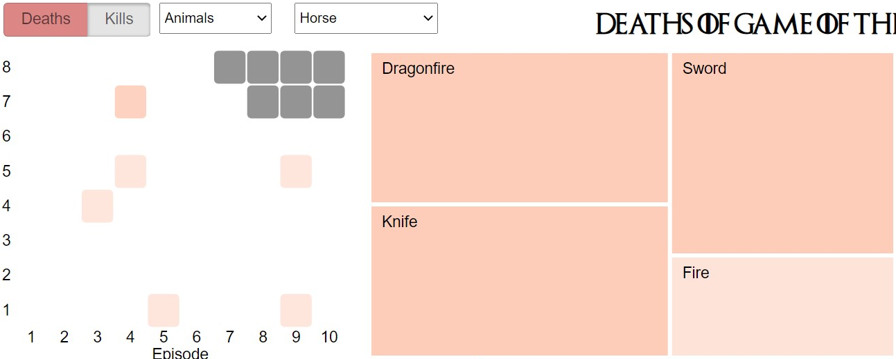

Figure 8. Filter options for the deaths of the horses

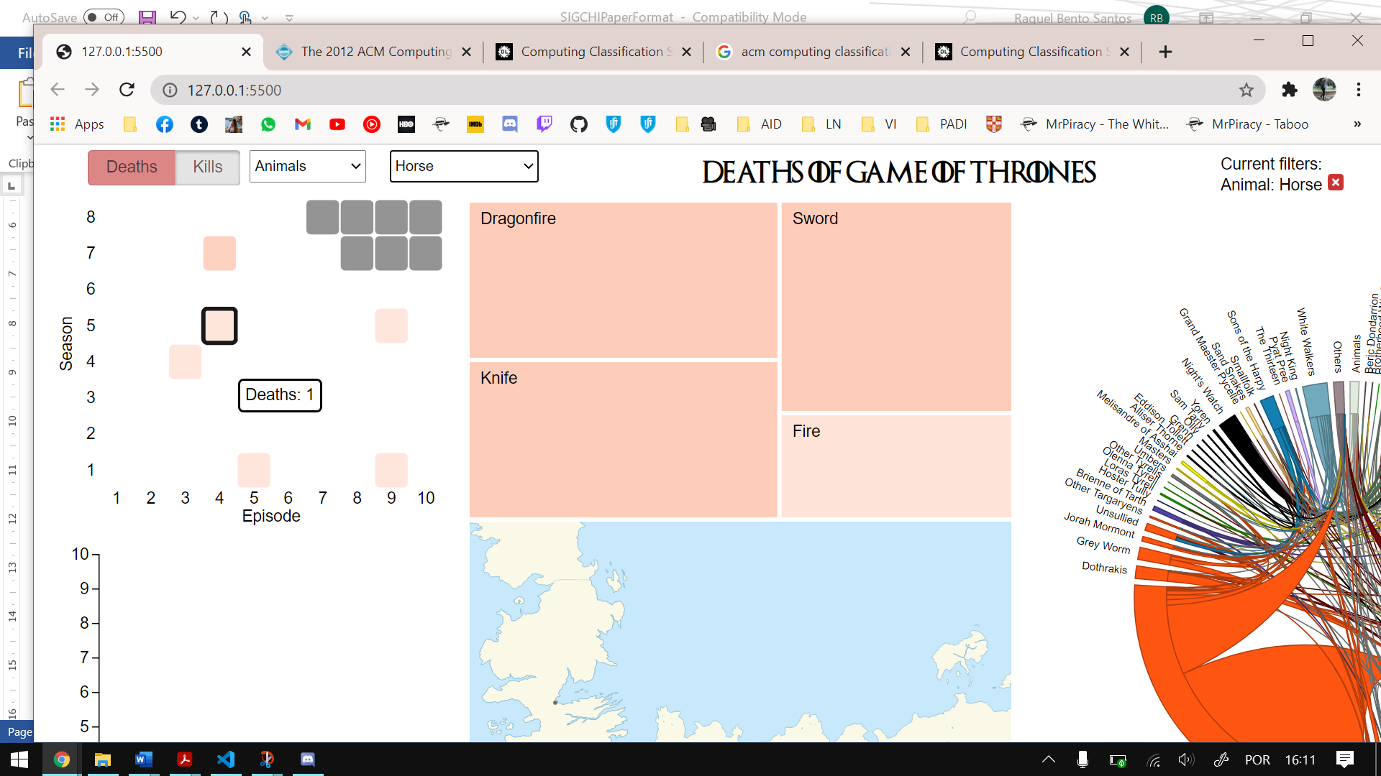

Figure 9. Number of deaths of the horses

1. Which gender has the most kills and deaths?

Filtering by gender (similarly to what was done in Figure 5 and 8), the heatmap will show the number of kills or deaths, according to the option selected. As an example, filtering the deaths of the female characters, we can see in Figure 10 the heatmap with their deaths number.

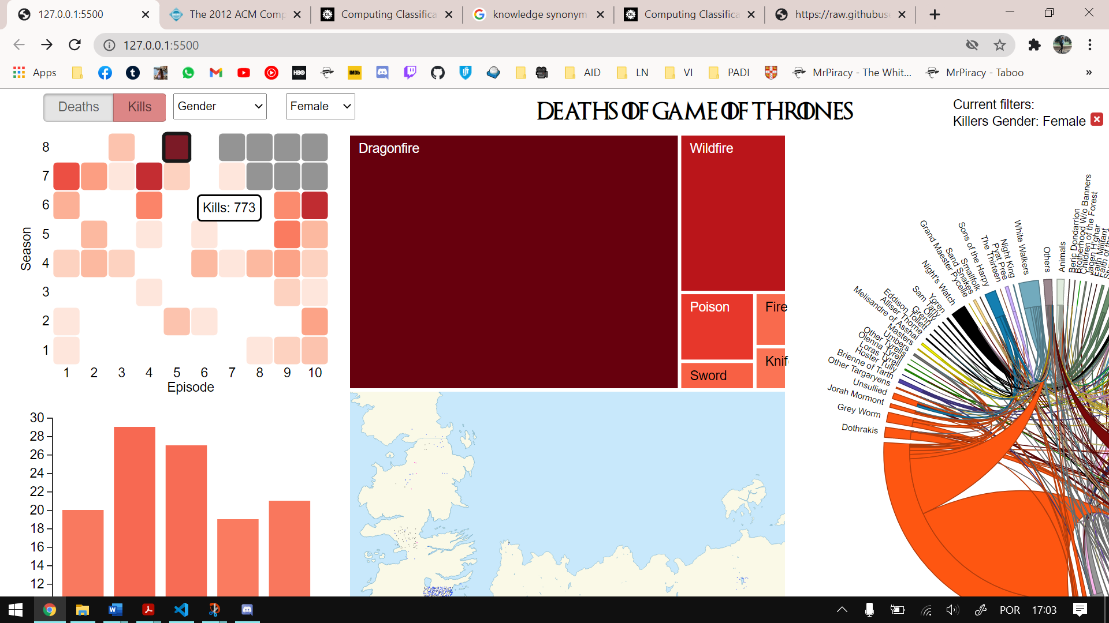

Figure 10. Number of deaths of the female characters

1. There is a preferred killing method according to the killer’s house?

Filtering by house and selecting the option “Kills” (similar to Figure 5) the tree map will show the killing methods used (Figure 11).

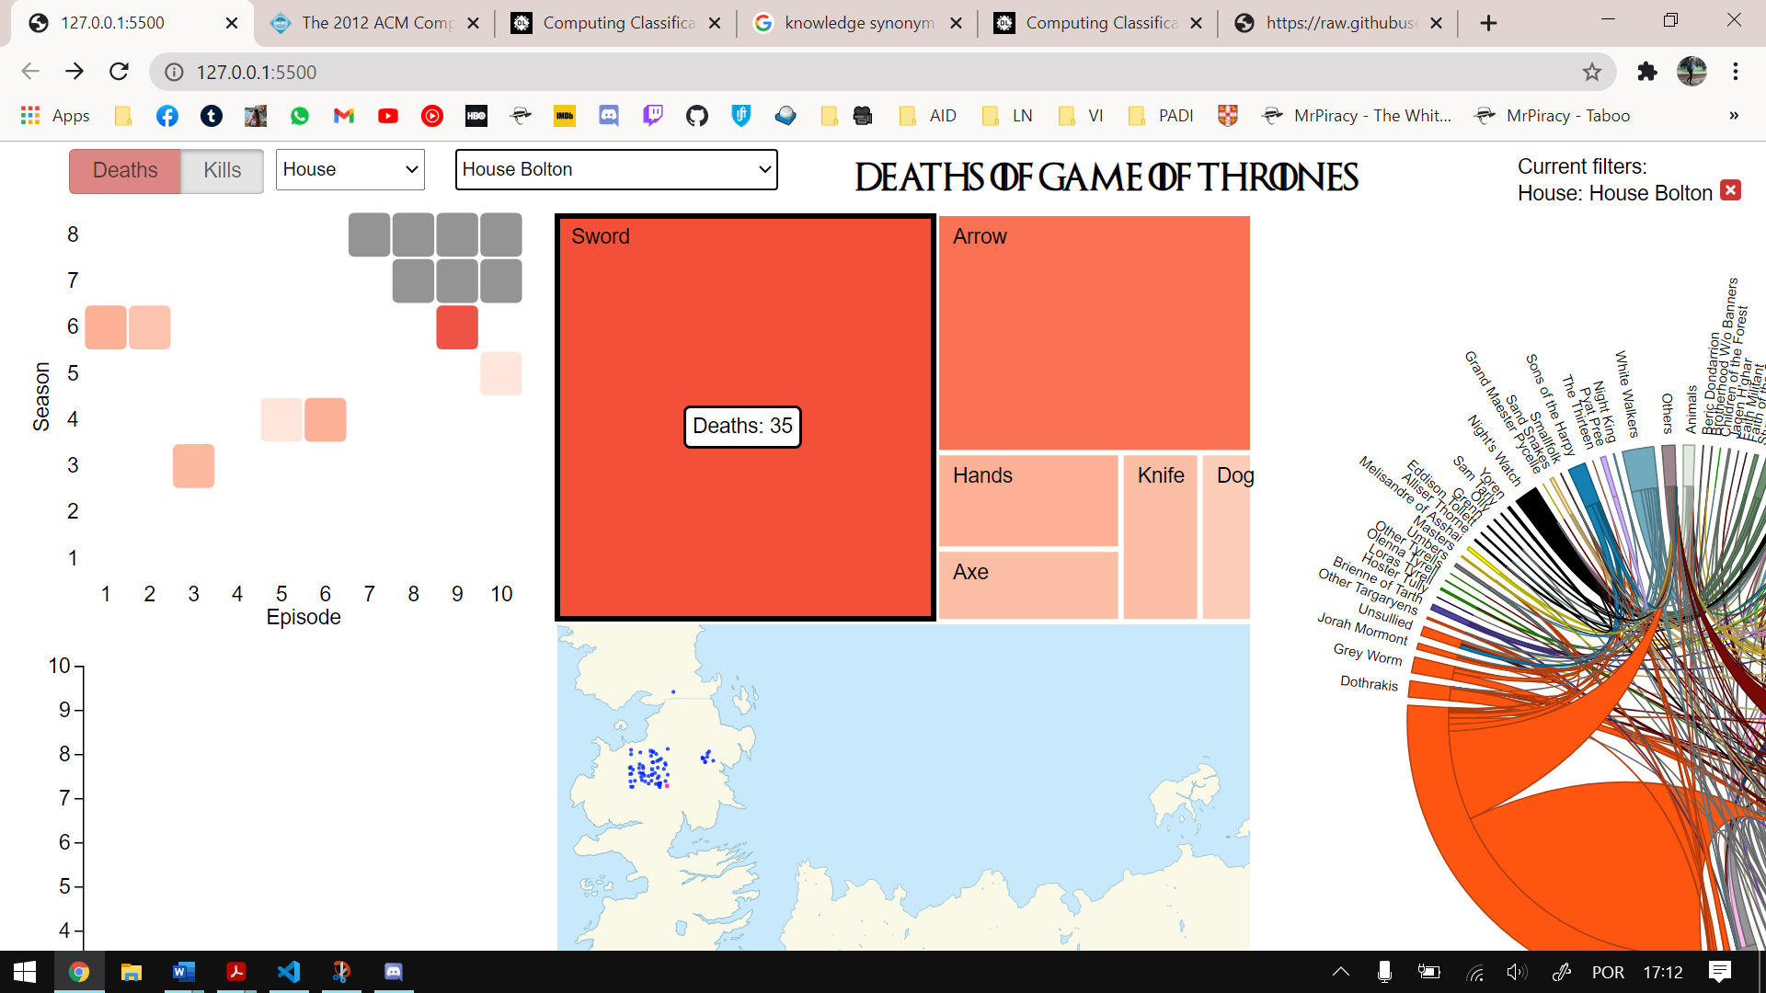

Figure 10. Killing methods used by House Bolton

1. Is the location of the deaths a factor when choosing the killing method?

By selecting a point in the map, the tree map will show the killing methods used in that locations. As an example, we clicked on a death in Winterfell (Figure 11) and the tree map show that the most used method is a sword (Figure 12). Clicking on Roseroad (Figure 13), we see that the most common killing method is dragon fire (Figure 14). This can be done for every location

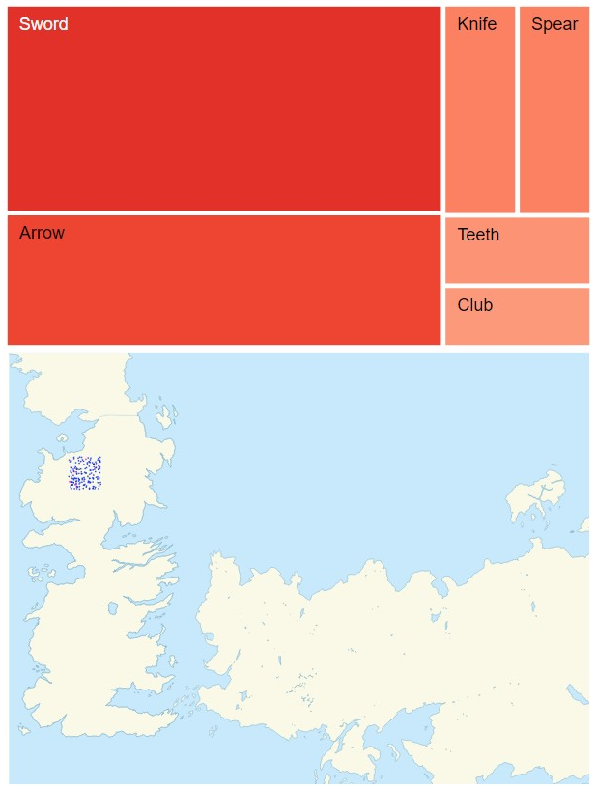

Figure 11. Deaths in Winterfell



Figure 12. Killing methods used in Winterfell

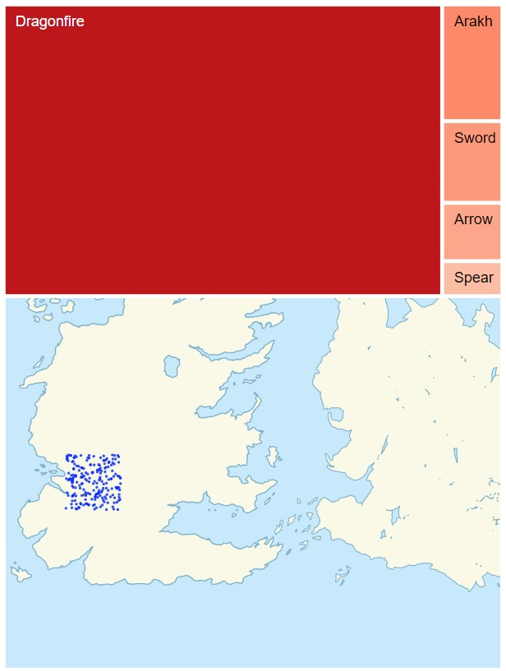

Figure 13. Deaths in Roseroad



Figure 14. Killing methods used in Roseroad

1. What percentage of TV show deaths were based on the books?

Filtering by each character and selecting the “Deaths” option we can see if the character is present in the books and if it died in them. As an example, Daenerys appears in four books, but her death isn’t based on the books considering that she only dies in the TV show as seen in Figure 15 and Figure 16. Ygritte’s death was based on the books and occurred in the same episode in both (Figure 17). Biter’s death was based on the books but only occurred two seasons later (Figure 18).

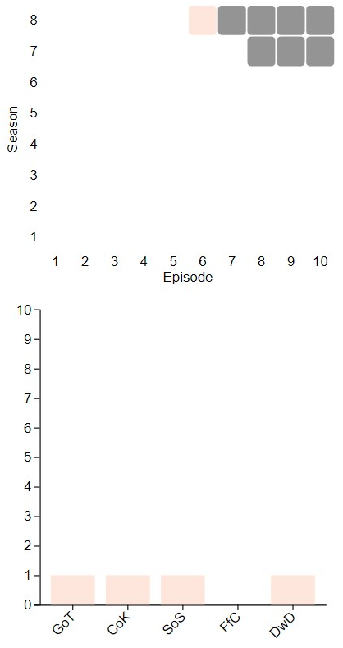

Figure 15. Death of Daenerys Targaryen



Figure 16. Presence in books of Daenerys Targaryen

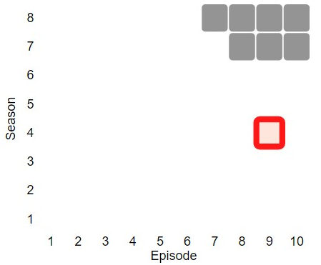

Figure 17. Death of Ygritte

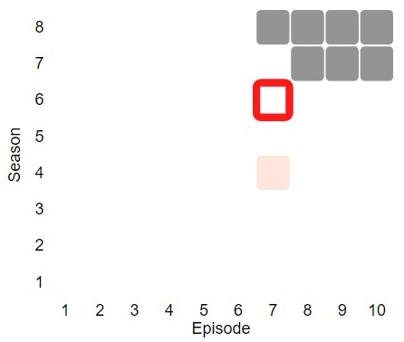

Figure 18. Death of Biter

1. Did the deaths in the TV show and the books occur by the same chronological order?

Filtering by each character and selecting the “Kills” option (as shown in Figure 6), the heatmap will show the episode of death and, with the red boarder, the estimate episode of death according to the book. We can see the previous mentioned examples in Figure 17 and Figure 18.

The remaining questions can be answered directly by analyzing the correspondent idiom.

Besides the answers to all the mentioned questions, we can also see that female characters tend to use fire or poison to kill while male characters prefer combat weapons like swords, knifes, arakhs and axes and also arrows and spears.

Also, we can see that the male kills are uniformly distributed through the seasons while there isn’t significant female kills before season 6. Since season 6, female kills grow exponentially and end up having approximately the double of the male kills.

# Implementation details

In the implementation of idioms such as the heatmap, the tree map, the chord diagram and the bar chart we started by checking examples of those idioms found in the internet done in previous versions of d3 and then adapt them in order to work in the most recent version of d3 (v6 at the moment). The map idiom was made from scratch and was achieved by using a svg [11] with the information of the borders of the map of the *Game of Thrones* world and by adding the information of each death to the respective area of the map.

The main challenges beyond the implementation of each idiom separately, were to link the idioms together, more specifically, every time we changed a filter in one idiom, we had to update all the other ones, the use of a tooltip shared by all idioms that adds more information about what the mouse is currently hovering, the use of a coherent colour scale (we chose a red colour scale because it fits the theme of deaths) and also the display of the overview in order to reduce the white spaces and to make it visually more attractive.

# conclusion & future work

With this project we learned that these visualizations are useful in order to understand a high quantity of information in a simple and easy way that otherwise wouldn’t be possible. They are also more personalized since we can configure each aspect of the visualization. The project also allowed us to improve our knowledge about the used languages and to learn to work with the d3.js framework.

The questions mentioned on the first checkpoint can all be answered by applying the correct filters.

If we were to start over, we would have done more research in the initial phase to improve the dataset considering than later we found other datasets with more details about each death. Also, we would prepare better the dataset considering that at each step we had to add a different column to solve the problems that start appearing.

If we had more time and money to invest to enrich our solution, we could implement more idioms to add more details about the deaths such as the reason of the death. Also, we could add illustrations of the killing methods and the characters to make our project more visual. We could also do some user testing to find out if the interface is in fact easy to use and make improvements based on that feedback.

# REFERENCES

1. Game of Thrones Interactive Viz by David Murphy. Last accessed in 16/12/2020 at <https://datasaurus-rex.com/gallery/gotviz-mkiii>
2. Game of Thrones Narrative Chart by Jeffrey Lancaster. Last accessed in 16/12/2020 at <https://jeffreylancaster.github.io/game-of-thrones/map/>
3. The Chaos Ladder by Patrick Gillespie. Last accessed in 16/12/2020 at <http://patorjk.com/vis/chaos-ladder/>
4. Narrative structure of *A Song of Ice and Fire* creates a fictional world with realistic measures of social complexity. Thomas Gessey-Jones, Colm Connaughton, Robin Dunbar, Ralph Kenna, Pádraig MacCarron, Cathal O’Conchobhair, Joseph Yose. Last accessed in 16/12/2020 at https://www.pnas.org/content/117/46/28582
5. Illustrated *Game of Thrones* Deaths by Shelly Tan. Last accessed in 16/12/2020 at https://www.washingtonpost.com/graphics/entertainment/game-of-thrones/
6. Deaths in the TV show *Game of Thrones*. Retrieved September 26, 2020 from <https://data.world/makeovermonday/2019w27/workspace/file?filename=game-of-thones-deaths.xlsx>
7. Deaths in the book collection *A Song of Ice and Fire*. Retrieved September 26, 2020 from <https://www.kaggle.com/mylesoneill/game-of-thrones?select=character-deaths.csv>
8. *Game of Thrones* wiki. Retrieved October 25, 2020 from <https://gameofthrones.fandom.com/>
9. *A Song of Ice and Fire* wiki. Retrieved October 25, 2020 from <https://awoiaf.westeros.org/>
10. *Game of Thrones* Episode Chapter Coverage. Retrieved October 25, 2020 from <https://joeltronics.github.io/got-book-show/bookshow.html>
11. Map of the *Game of Thrones* world. Retrieved November 30, 2020 from https://commons.wikimedia.org/wiki/File:The_Seven_Kingdoms_Location.svg